

**Introduction to Database (CCCS215 Project)**

**Cinema management system**

By

Arjwan alqarni 2110253

Aryam AL-Sulami 2110099

Noura Ahmed Aljehani 2111335

Wrood Fawaz Allibdi 2112158

# Problem description

Our idea about cinema. We can solve the problem of security of cinemas applications by improving the security and services. We made many options to users to book any movie and enjoy it. We also have snacks like popcorn and drinks.

# Business rule

* Cinema displays many Movie
* A movie can be booked by many bookers
* Cinema has many book records that holds needed information
* Cinema provides many different type of snacks
* Snacks can be ordered in book record
* Each reservation should be paid. Each payment is for one reservation

# ER diagram

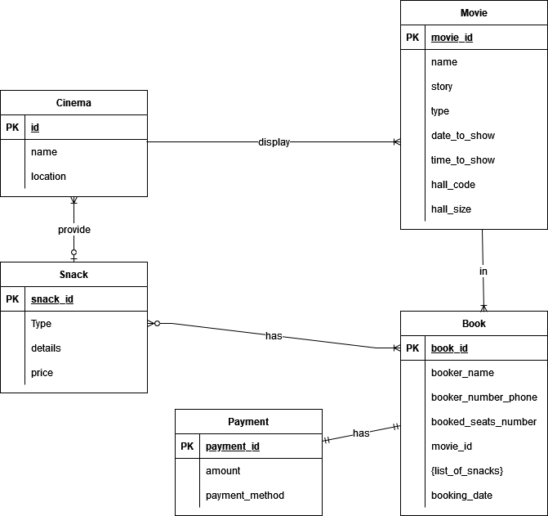

# Relations

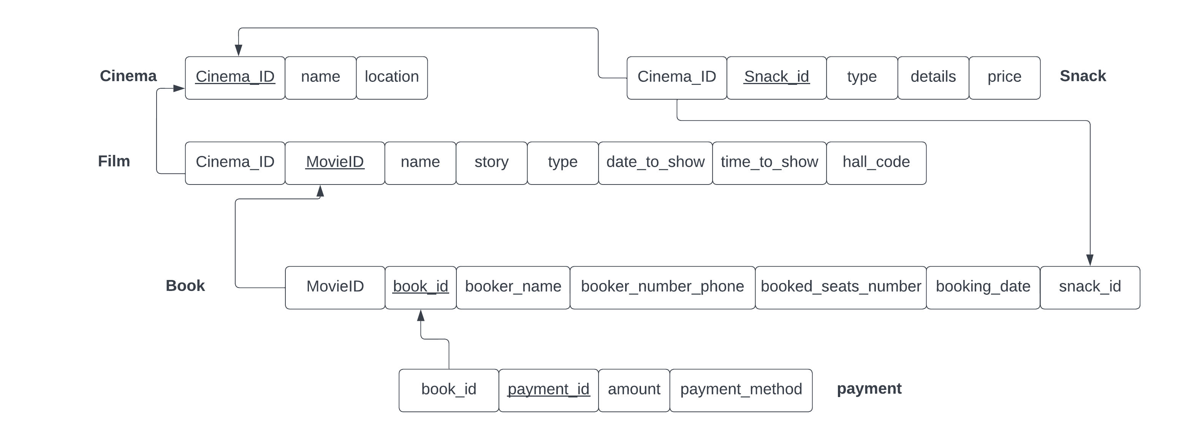

# Normalization

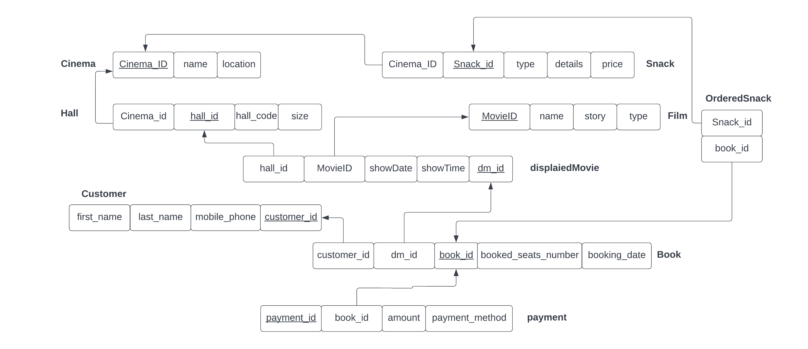

Now we have relations that are in the **3NF** as you can see:

* there is *no repeating group*
* all of them are full dependency
* no transitive

# Normalized Tables

|  |  |  |
| --- | --- | --- |
| Cinema | | |
| Column name | Data type Size | Constraints |
| Cinema_id | Int | Primary key |
| Name | Varchar(50) | Not null |
| Location | Varchar(256) | Not null |

|  |  |  |
| --- | --- | --- |
| Hall | | |
| Column name | Data type Size | Constraints |
| Hall_id | Int | Primary key |
| Hall_code | Varchar(10) | Not null |
| Hall_size | int | Not null |
| Cinema_id | Int | Foreign key on Cinema |

|  |  |  |
| --- | --- | --- |
| Movie | | |
| Column name | Data type Size | Constraints |
| Movie_id | Int | Primary key |
| name | Varchar(50) | Not null |
| story | Varchar(256) | Not null |
| type | Varchar(25) | Not null |

|  |  |  |
| --- | --- | --- |
| DisplaiedMovie | | |
| Column name | Data type Size | Constraints |
| Dm_id | Int | Primary key |
| Date_to_show | Date | Not null |
| Time_to_show | Varchar(10) | Not null |
| Movie_id | Int | Foreign key on Movie |
| Hall_id | Int | Foreign key on Hall |

|  |  |  |
| --- | --- | --- |
| Customer | | |
| Column name | Data type Size | Constraints |
| Customer_id | Int | Primary key |
| First_name | Varchar(25) | Not null |
| Last_name | Varchar(25) | Not null |
| Mobile_phone | Varchar(25) | Not null |

|  |  |  |
| --- | --- | --- |
| Snack | | |
| Column name | Data type Size | Constraints |
| Snack_id | Int | Primary key |
| Type | Varchar(25) | Not null |
| Details | Varchar(256) | Not null |
| Price | Float | Not null |
| Cinema_id | Int | Foreign key on Cinema |

|  |  |  |
| --- | --- | --- |
| Book | | |
| Column name | Data type Size | Constraints |
| Book_id | Int | Primary key |
| Booked_seats_number | Int | Not null |
| Booking_date | Date | Not null |
| customer_id | Int | Foreign key on Customer |
| dm_id | Int | Foreign key on DisplaiedMovie |

|  |  |  |
| --- | --- | --- |
| OrderedSnack | | |
| Column name | Data type Size | Constraints |
| Book_id | Int | Foreign key on book |
| Snack_id | Int | Foreign key on snack |

|  |  |  |
| --- | --- | --- |
| Payment | | |
| Column name | Data type Size | Constraints |
| Payment_id | Int | Primary key |
| Amount | Float | Not null |
| Payment_method | Varchar(50) | Not null |
| Book_id | Int | Foreign key on Book |

# Functional Dependencies

* Cinema_id 🡪 Name, Location
* Hall_id 🡪 Hall_code, Hall_size, Cinema_id
* Movie_id 🡪 name, story, type
* Dm_id 🡪 Date_to_show, Time_to_show, Movie_id, Hall_id
* Customer_id 🡪 First_name, Last_name, Mobile_phone
* Snack_id 🡪 Type, Details, Price, Cinema_id
* Book_id 🡪 Booked_seats_number, Booking_date, customer_id, dm_id
* OrderedSnack 🡪 (Book_id, Snack_id)
* Payment_id 🡪 Amount, Payment_method, Book_id

# Creating tables

create table cinema (

Cinema_id Int Primary key,

Name Varchar(50) Not null,

Location Varchar(256) Not null

);

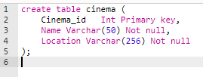



create table hall (

Hall_id Int Primary key,

Hall_code Varchar(10) Not null,

Hall_size Int Not null,

Cinema_id Int,

CONSTRAINT FK_Cinema FOREIGN KEY (Cinema_id)

REFERENCES Cinema(Cinema_id)

);

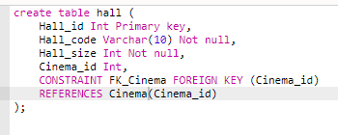



create table movie (

Movie_id Int Primary key,

name Varchar(50) Not null,

story Varchar(256) Not null,

type Varchar(25) Not null,

);

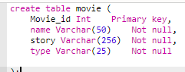



create table DisplaiedMovie (

Dm_id Int Primary key,

Date_to_show Date Not null,

Time_to_show Varchar(10) Not null,

Movie_id Int,

Hall_id Int,

CONSTRAINT FK_hall FOREIGN KEY (Hall_id)

REFERENCES hall(Hall_id),

CONSTRAINT FK_movie FOREIGN KEY (Movie_id)

REFERENCES Movie(Movie_id)

);

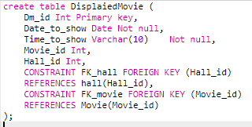



create table Snack (

Snack_id Int Primary key,

Type Varchar(25) Not null,

Details Varchar(256) Not null,

Price float Not null,

Cinema_id int,

CONSTRAINT FK_snack_Cinema FOREIGN KEY (Cinema_id)

REFERENCES Cinema(Cinema_id)

);

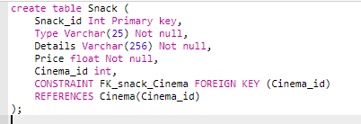



create table Customer (

Customer_id Int Primary key,

First_name Varchar(25) Not null,

Last_name Varchar(25) Not null,

Mobile_phone Varchar(25) Not null

)

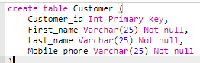



create table Book (

Book_id Int Primary key,

Booked_seats_number Int Not null,

Booking_date Date Not null,

customer_id Int,

dm_id Int,

CONSTRAINT FK_customer FOREIGN KEY (customer_id)

REFERENCES Customer(customer_id),

CONSTRAINT FK_DisplaiedMovie FOREIGN KEY (dm_id)

REFERENCES DisplaiedMovie (dm_id)

);

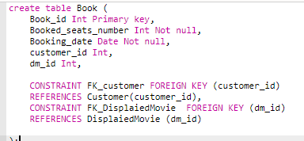



create table OrderedSnack (

Snack_id Int,

Book_id Int,

CONSTRAINT FK_Snack FOREIGN KEY (Snack_id)

REFERENCES Snack(Snack_id),

CONSTRAINT FK_Book FOREIGN KEY (Book_id)

REFERENCES Book (Book_id)

);

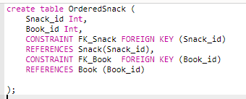



create table Payment (

Payment_id Int Primary key,

Amount float Not null,

Payment_method Varchar(50) Not null,

Book_id Int,

CONSTRAINT FK_Book_payment FOREIGN KEY (Book_id)

REFERENCES Book (Book_id)

);

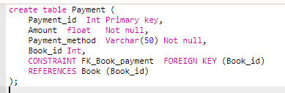



# Rows insert

insert into cinema values (1,'fox cinema', 'location 1');

insert into cinema values (2,'KSA cinema', 'location 2');

insert into cinema values (3,'Golden cinema', 'location 3');

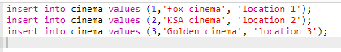



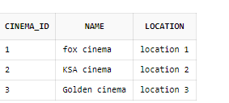

insert into hall values (1,'h1-1',50,1);

insert into hall values (2,'h1-2',50,1);

insert into hall values (3,'h2-1',75,2);

insert into hall values (4,'h2-2',75,2);

insert into hall values (5,'h3-1',60,3);

insert into hall values (6,'h3-2',60,3);

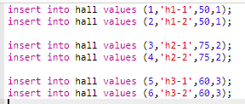



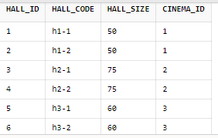

insert into movie values (1,'name 1' , 'story 1' , 'type 1');

insert into movie values (2,'name 2' , 'story 2' , 'type 2');

insert into movie values (3,'name 3' , 'story 3' , 'type 3');

insert into movie values (4,'name 4' , 'story 4' , 'type 4');

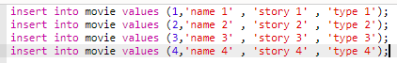



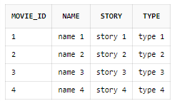

insert into DisplaiedMovie values (1,to_date('2022-11-01', 'yyyy-mm-dd'), '13:30',1,1);

insert into DisplaiedMovie values (2,to_date('2022-11-01', 'yyyy-mm-dd'), '15:30',2,1);

insert into DisplaiedMovie values (3,to_date('2022-11-02', 'yyyy-mm-dd'), '12:30',3,3);

insert into DisplaiedMovie values (4,to_date('2022-11-01', 'yyyy-mm-dd'), '16:00',4,4);

insert into DisplaiedMovie values (5,to_date('2022-11-01', 'yyyy-mm-dd'), '18:30',4,6);

insert into DisplaiedMovie values (6,to_date('2022-11-02', 'yyyy-mm-dd'), '15:30',3,2);

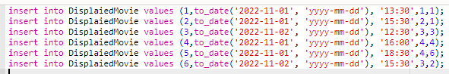



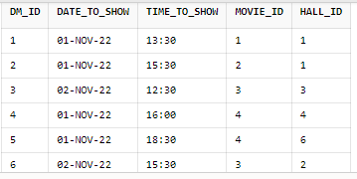

insert into customer values (1, 'Mohammed', 'Saber', '123456789');

insert into customer values (2, 'ALi', 'Jaber', '123456789');

insert into customer values (3, 'Khaled', 'Qaser', '123456789');

insert into customer values (4, 'Najwa', 'Hamed', '123456789');





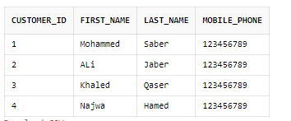

insert into book values (1,2,to_date('2022-10-22', 'yyyy-mm-dd'), 1,6);

insert into book values (2,2,to_date('2022-10-25', 'yyyy-mm-dd'), 1,4);

insert into book values (3,4,to_date('2022-10-22', 'yyyy-mm-dd'), 2,1);

insert into book values (4,4,to_date('2022-10-27', 'yyyy-mm-dd'), 3,3);

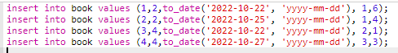



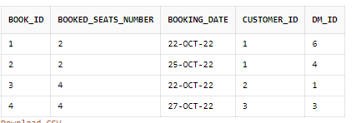

insert into payment values (1,500,'Cash', 1);

insert into payment values (2,400,'Cash', 2);

insert into payment values (3,300,'Cash', 3);

insert into payment values (4,500,'Card', 4);

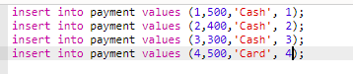



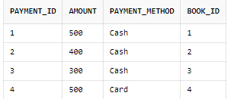

# Data Retrieval Queries

## Get payment method and number of records that contains same payment method.

select PAYMENT_METHOD, count(PAYMENT_METHOD)

from payment

group by PAYMENT_METHOD;



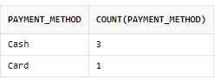

## Get name of film and name of cinema that showing it.

select movie.name as movie, cinema.name as cinema

from movie, cinema, hall, DisplaiedMovie

where

DisplaiedMovie .movie_id = movie.movie_id

and

DisplaiedMovie .hall_id = hall.hall_id

and

hall.cinema_id = cinema.cinema_id

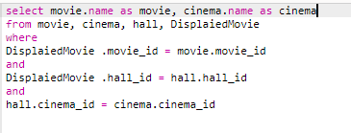

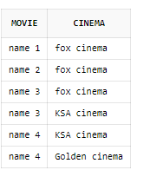

## Get name of film and number of its books.

select movie.name , count (movie.name)

from movie join displaiedmovie on

movie.movie_id = displaiedmovie.movie_id

join book on

book.dm_id = displaiedmovie.dm_id

group by movie.name

order by count (movie.name) desc

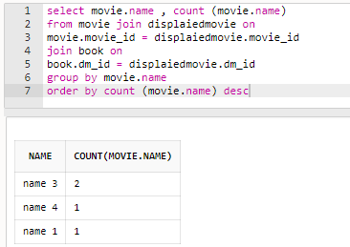

## Get name of films that does not have any book.

select movie.name

from movie

where movie.movie_id not in

(

select movie.movie_id

from movie, displaiedmovie, book

where

movie.movie_id = displaiedmovie.movie_id

and

displaiedmovie.dm_id = book .dm_id

)

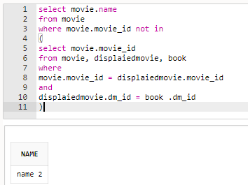

## Get name of films that booked by specific customer

select movie.name as movie, concat(customer.First_name ,Concat(' ',customer.Last_name)) as customer

from movie, DisplaiedMovie , book, customer

where

DisplaiedMovie .movie_id = movie.movie_id

and

DisplaiedMovie .dm_id = book.dm_id

and

book.customer_id = customer.customer_id

and

customer.customer_id = 1

